**ADVANCE EXCEL ASSIGNMENT 6**

Q.1. What are the various elements of the Excel interface? Describe how they’re used.

Answer: There are many elements in EXCEL interface, here are following:

* Quick access toolbar: Gives us a shortcut for redo, undo, save options. We can modify the shortcuts.
* Name box: shows the cell selected
* Select all button : helps in selection of whole worksheet
* Row headings: represents the number of row on which we are working on
* Sheet tab controlling buttons: helps to add, delete or create more sheets according to requirement.
* Status bar: The status bar at the bottom of Office programs displays status on options that are selected to appear on the status bar. It can also be modified.
* Sheet tabs: represents different sheets
* Formula bar: it contains the contents of the active cell. When any formula is used, the formula appears here while the value of the formula appears in the cell.
* Ribbon tabs: a group of commands
* Column heading: represents the number of column on which we are working on
* Title bar: name of the document we are working on
* Active Cell: selected cell in which we are working
* Vertical scroll bar: enables to scroll the content up and down
* Zoom controls: helps to view the content from close and far (zoom in or zoom out) by %
* Horizontal scroll bar: enables to scroll the content right and left

Q.2. Write down the various applications of Excel in the industry.

Answer:

* Data entry and storage
* Performing calculations
* Data analysis and interpretation
* Accounting and budgeting
* Collection and verification of business data
* Reporting and visualization
* Forecasting
* Administrative and Managerial duties

Q.3. On the ribbon, make a new tab. Add some different groups, insert commands in the groups and name them according to their commands added. Copy and paste the screenshot of the steps you followed.

Answer:

Step 1: Go to options

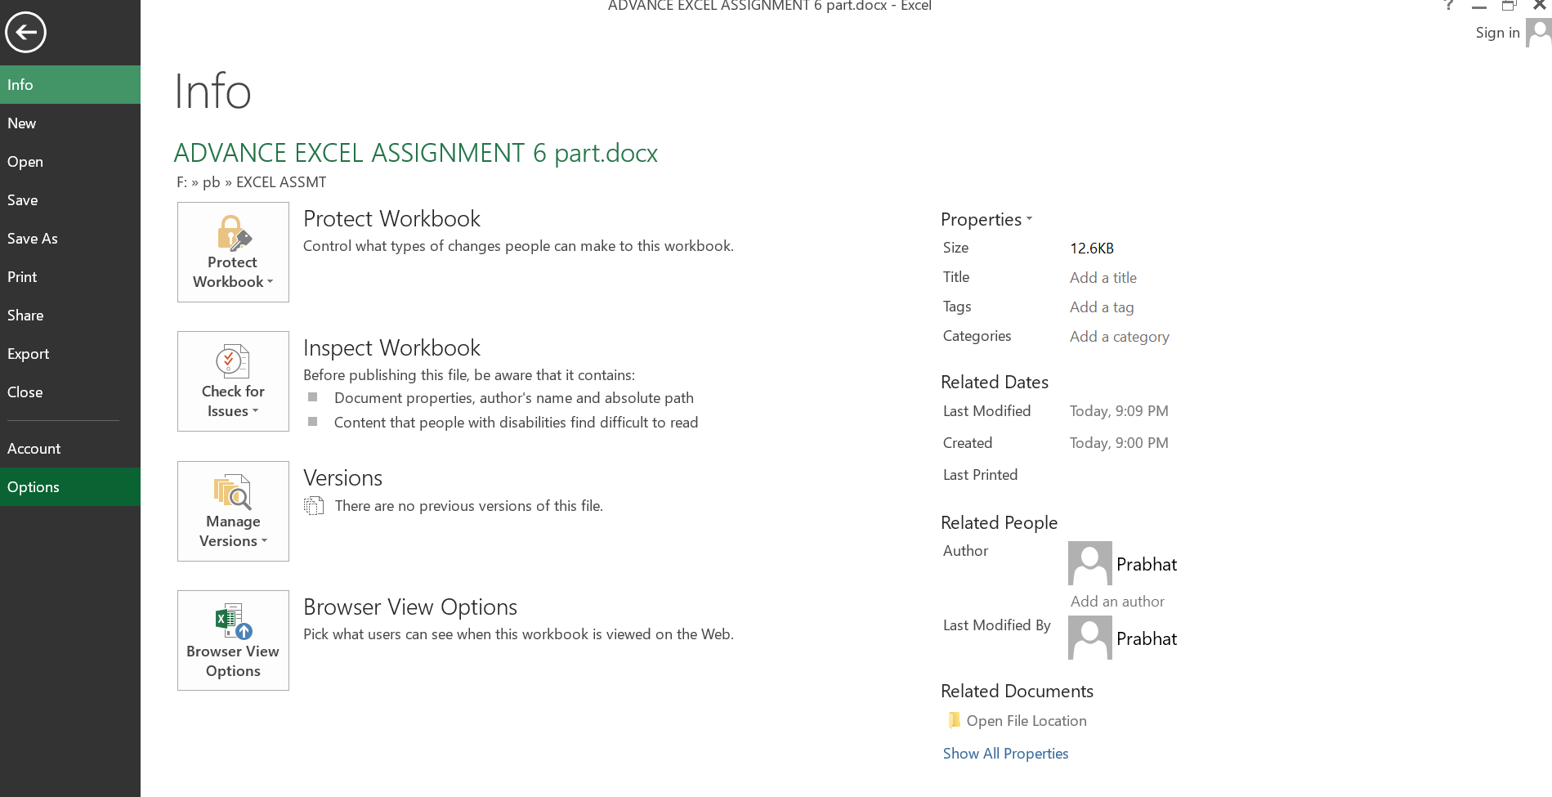

Step 2: then go to customize ribbons

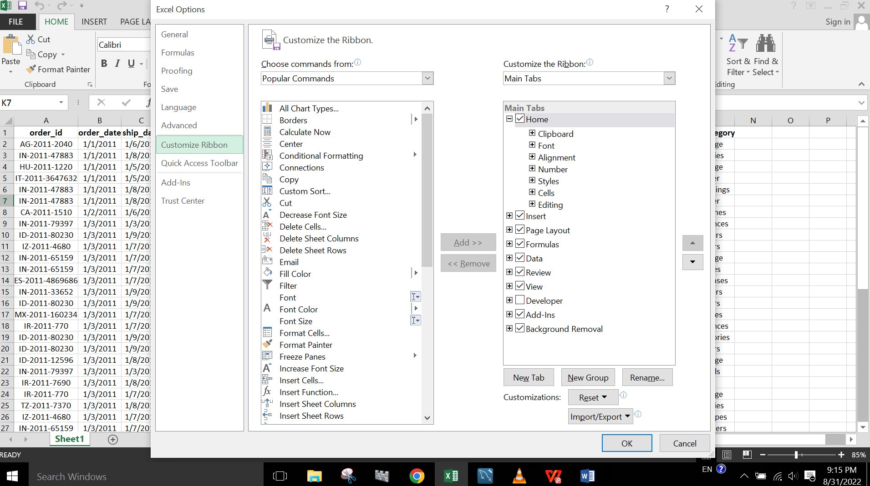

Step 3: Add new tab and rename it. Then add new group and rename it accordingly.

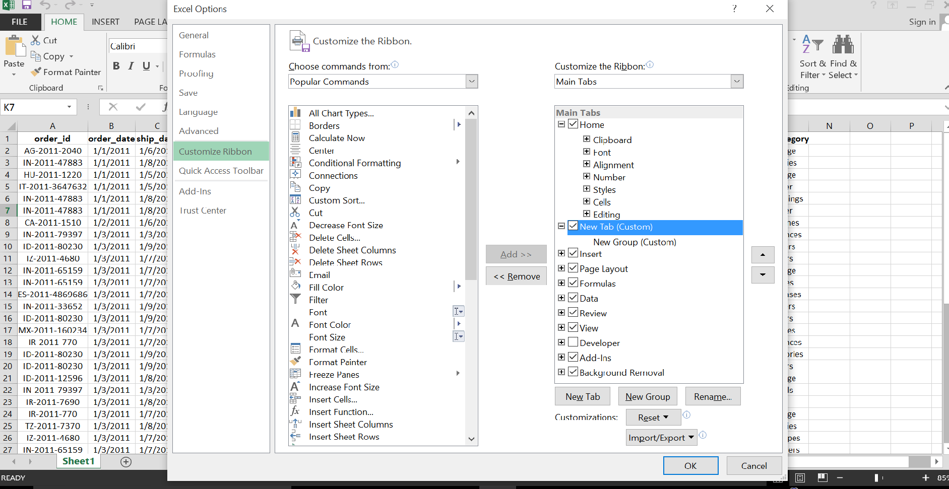

Step 4: After adding the command click ok.

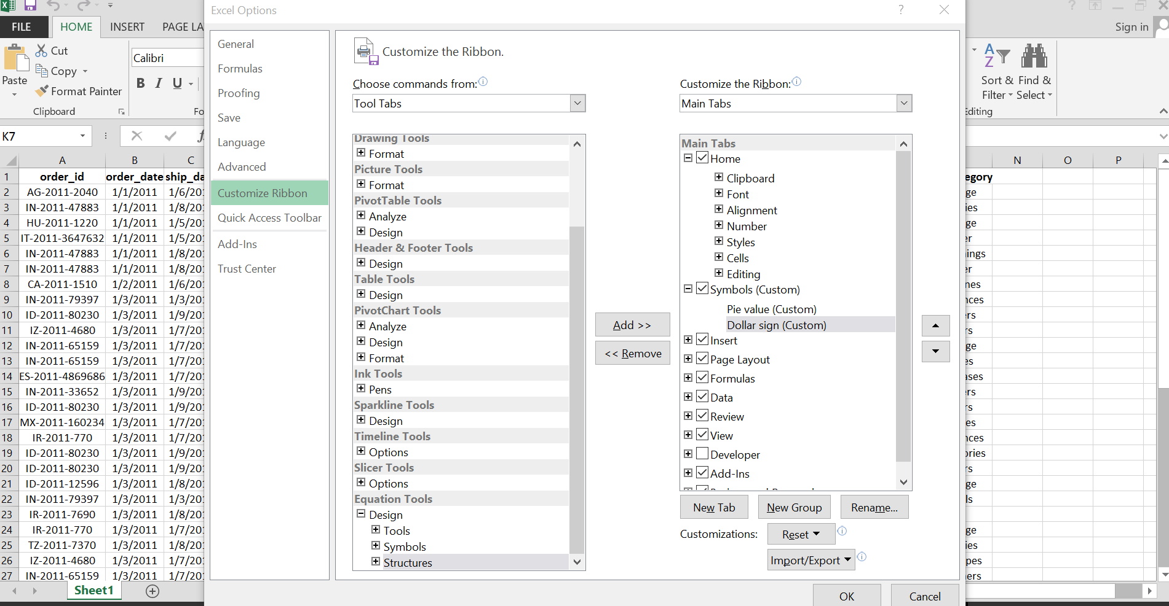

Step 5: Now at the top with other tools we can see the customized tool as well.

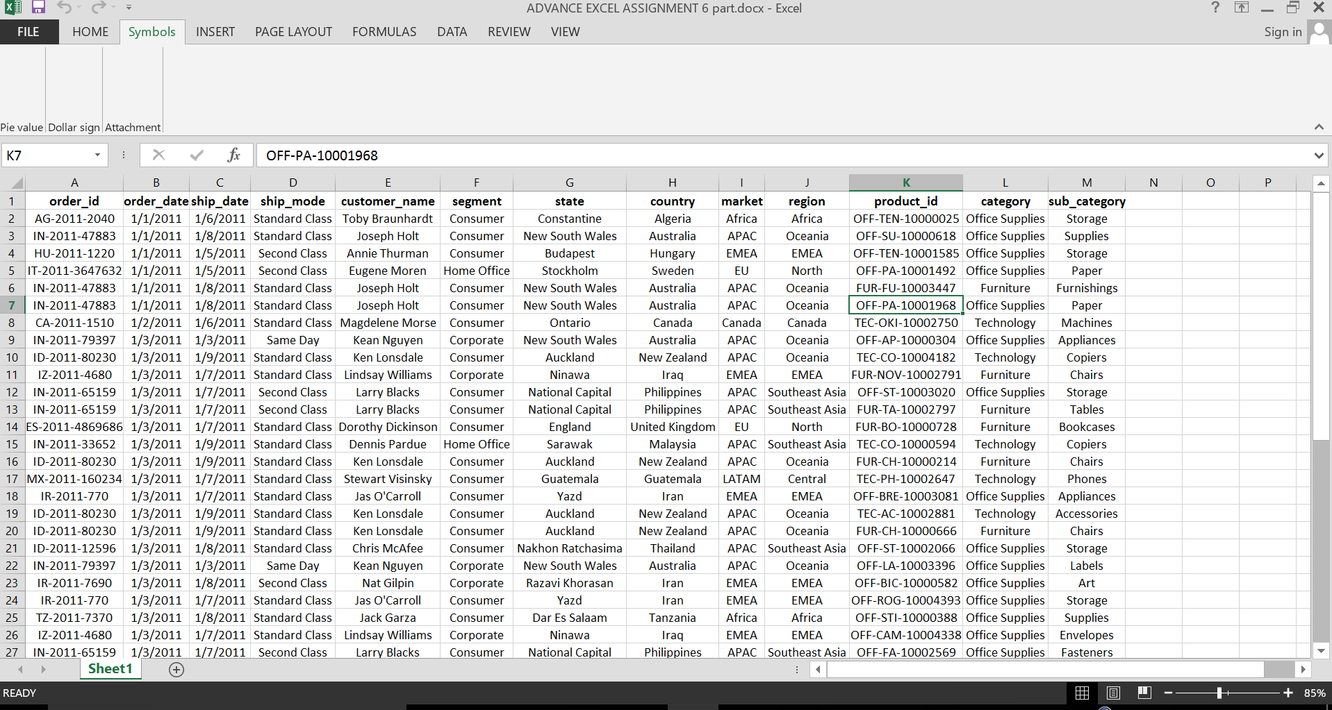

Q.4. Make a list of different shortcut keys that are only connected to formatting with their functions.

Answer:

* Ctrl+a – select all text
* Ctrl + x – cut
* Ctrl+c – copy
* Ctrl+v – paste
* Ctrl +end – end the document
* Alt + f – file menu options in current sheet
* Alt+e – edit options in current sheet
* Shift + del – cut selected item
* Ctrl+b – bold highlighted section
* Ctrl+p – print the window
* Ctrl+f – opens find box
* Ctrl+I – italic highlighted section
* Ctrl+u – underline highlighted section
* Ctrl + z – undo
* Ctrl+y – redo
* Ctrl+esc – open start menu

These are some shortcut keys that are only connected to formatting their functions.

Q.5. What distinguishes Excel from other analytical tools?

Answer: Microsoft EXCEL helps in organizing and sorting the data in a meaningful and customizable manner. This feature makes it easier for the user to take action on the data collected.

Q.6 Create a table and add a custom header and footer to your table.

Answer: I have added the screenshot of the custom header and footer of the sheet.

